Software Design Document

Data Analysis Tool: NSW Traffic Penalties

Brianne Byer

Wonwoo Choi

Marco Querzola

Table of Contents

1.0 System Vision 3

1.1 Problem Background 3

1.2 System Overview 3

1.3 Potential Benefits 3

2.0 Requirements 4

2.1 User Requirements 4

2.2 Software Requirements 4

2.3 Use Cases & Use Case Diagrams 4

3.0 Software Design and System Components 6

3.1 Software Design 6

3.2 System Components 6

3.2.1 Functions 6

3.2.2 Data Structures / Data Sources 6

3.2.3 Detailed Design 6

4.0 User Interface Design 7

Structural Design 7

Structure of Product (Hierarchy Chart) 7

4.1 Visual Design 8

Main Page 8

Distribution of Cases in each offence code 9

All cases captured by radar or camera 9

Cases caused by mobile phone usage 10

Penalty caused in School Zone 11

# System Vision

## Problem Background

Cars are closely related to our lives and many people are driving. Driving a car is very convenient, but at the same time, there are quite a few rules given to the driver for safety. So, our team is going to show which penalties are awarded the most in the project so that people are alert or careful about it. NSW is Australia's most populous state. (Australian Bureau of Statistics,2022) That's why our team is going to do it on a trial basis with data from NSW. In this program, you can specify a specific time period and view the penalty history that occurred during that time period. In order to make it easier for users to recognize visual information, we will convert the information into a graph and easily deliver it to users. There are four main pages in this program. “Main page", "Distribution of Cases in each offence code”, "All cases captured by radar or camera", "Cases caused by mobile phone usage" and "Penalty caused in School Zone". The main page is a page that users can see when they first access, and there are buttons that allow users to set a period or display only events near the school. On the other two pages except "Penalty reasoned in school Zone" and "Main page", the user sets a period, specifies whether to display only events near the school, and presses the search button to automatically generate a graph of the result value, and the user can also initialize the conditions using the clear button. Finally, on the Penalty Caused in School Zone page, when the user clicks the Search button after specifying a period, penalties that occurred near the school during the selected period are displayed as a graph. Every page has a navigation bar, which allows you to move to another page fluidly.

## System Overview

In our system user can input maximum 3 conditions for searching. Start date, End date and School Zone check box. Start date and End date condition to set the period of searching. If the user clicks the Start date or End date text box, then the calendar will pop up and user can select date on there. User can tick the box to see the only penalty given in school zone area. Once the user selects all the condition user can click “Search” button to generate graph. However, main page will only generate raw data without graph, but rest of the page will generate graph. Once the user click “Reset” button that locate next to “Search” button, the input conditions will be null. User can move the page by using navigation bar that locate left side of the page. Depend on the page the navigation bar will be change.

## Potential Benefits

By using this program, users can learn about which traffic rules are most poorly followed and many people are caught. By knowing this information, users will be most alert to traffic rules and will be able to try not to break them in the future. Also, if traffic regulators use this program to find out which laws are best broken, they will be able to study how to prepare for the most common rules.

# Requirements

## User Requirements

This program is designed for the user to be able to search through a set of data relating to traffic penalties in NSW between 2011 and 2018. The user will first be able to select a period they want to search from ranging from the whole data set to a day or week window. Once the period is selected the user can search for certain key words such as mobile phone usage or drink driving offences. During a selected time period the user will be able to produce a chart which shows a distribution of number of cases in each offence code, this will help to get an idea of what is the most common breach of NSW traffic rules. This program will be a very useful analysis tool and would help those working in analytical roles within the NSW government especially those involved in the Transport for NSW department.

## Software Requirements

R1.1 The program shall ask for input for a date range between 2011-2018, this can be anywhere from years to days.

R1.2 The program will then provide a search box where user can filter offences by type of offence or various keywords.

R1.3 The program shall provide a list of offences relevant to type/keyword. User can click on each offence to get more information.

R1.4 The program shall provide a chart showing the distribution of number offences in each code.

In this section you detail what the requirements for the software are. What functionality will it provide? This is usually a formal listing, with requirements often using the word ‘Shall’. IE:

R1.1 The program shall accept multiple file names as arguments from the command line.

R1.2 Each file name can be a simple file name or include the full path of the file with one or more levels.

etc …

Can be primarily functional requirements, though you may include other types if you think of them.

## Use Cases & Use Case Diagrams

In this section you provide some use cases showing how people may use your software.

# Software Design and System Components

## Software Design

A block diagram/flowchart of how your software might work

## System Components

### Functions

Preliminary list of all functions in the software. For each function in the list the following information is provided:

* a brief description of what it does (1 or 2 sentences);
* a list of the input parameters, and their data types, and what they are used for;
* a list of any side effects caused by the function (ie change global or member variables, changes data passed by reference from calling function etc)
* a description of the function’s return value

### Data Structures / Data Sources

List of all data structures in the software (eg linked lists, trees, arrays etc) or eternal data sources. For each data structure in the list the following information is provided:

* Type of structure (tree, list etc),
* Description of where and how it is used
* List of data members, and what each one is for do
* List of functions that use it

### Detailed Design

Pseudocode for all non-standard / non-trivial algorithms that operate on data structures

# User Interface Design

This is your initial interface design. Describe the tools you used for this design stage and any key findings that informed your design. This introduction is descriptive and should explain what you have completed for the actual design work you will present in the sub-sections below.

# Structural Design

Structural design refers to the navigational and information structure of your product – the structure that supports the interface layout. How will you structure your product? How will you group your information? How will you navigate through your product? Why? This can take the form of a diagram showing structure and hierarchy, supported by a discussion and justification of your choices. Why have you made these design choices? Describe and outline the structure of your interface and of your information.

## Structure of Product (Hierarchy Chart)

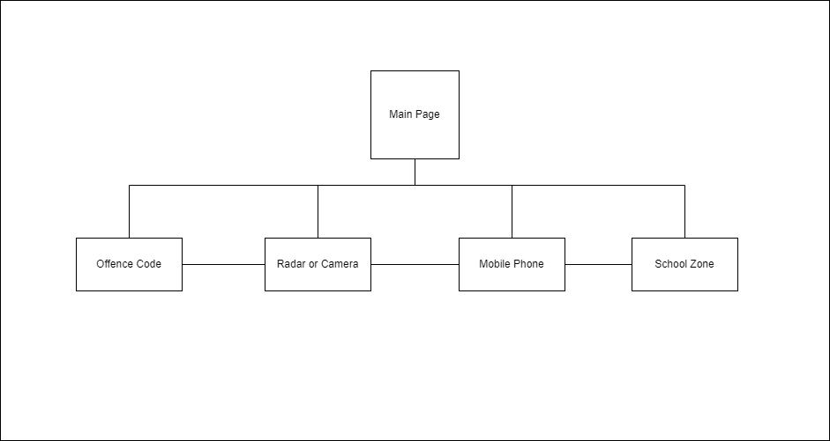

First of all, when the user executes the program, they will be able to see the main page. In the main page user can select period on the top of the page. Once the user complete to input period user can search the data during that period by clicking ‘Search’ button. User can reset the data by clicking ‘Reset’ button that locate next to search button. By default, main page will display all of the data as table. User can move to another page by using vertical navigation bar that locate in right side of page. According to the current page the colour of that page on nav bar will be changed, so the user can easily recognize what page they are looking.

All cases captured by radar or camera page, Cases caused by mobile phone usage page, Penalty caused in School Zone page and Distribution of Cases in each offence code page will show distribution of offence code as graph. As same as main page user can select period and by clicking ‘Search’ button user can search the distribution of cases in selected period. User can press ‘Reset’ button to reset the value of period. If there is no period selected the page will present distribution of cases from oldest to latest data with graph. By ticking ‘School Zone’ check box user only can found the case from school zone during selected period. As same as other pages this page also has nav bar that can help user to move to other pages.

Each page will have appropriate type of graph.

## Visual Design

Detail your visual design: Layout, visual elements, icons, graphics, style, colour, fonts general screen designs. This can be sketches, wireframes, mockups etc, supported by a discussion, explanation, and justification of your choices.

## Main Page

This is main page that user will face firstly. User can select start date and end date to choose period and check box “School Zone” will decide whether the user going to contain penalty data happened in school zone. When the user entered and if there is no condition then all of the data will be displayed by default. Once the user input conditions such as date and school zone and click search button then appropriate data will be displayed.

## Distribution of Cases in each offence code

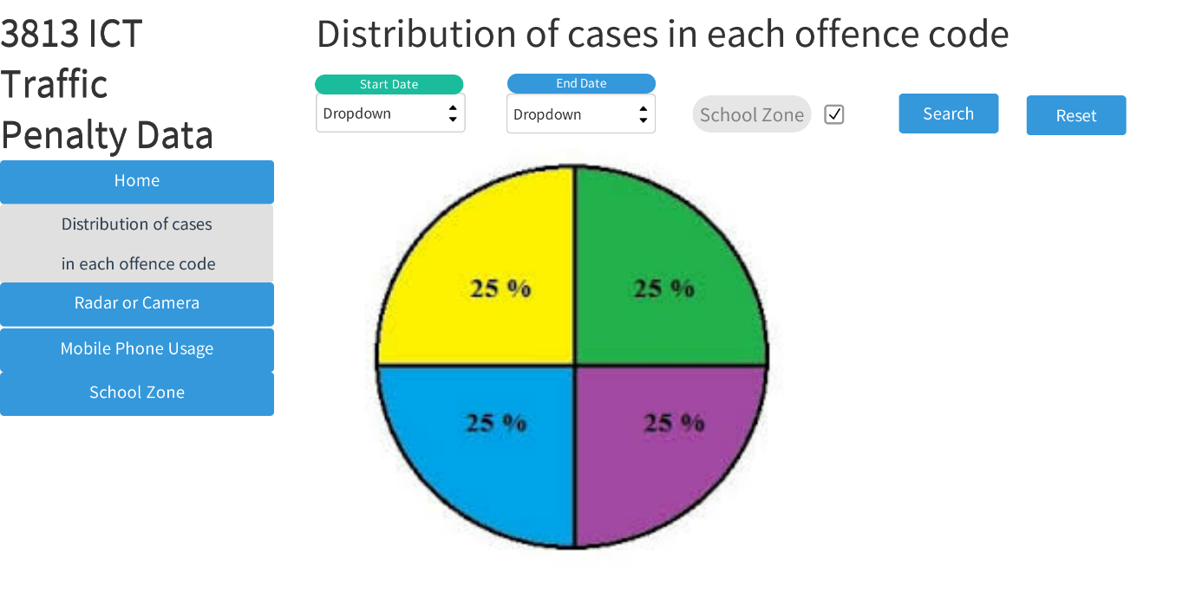

In navigation bar located in left side of the page the “Distribution of cases in each offence code” changed into grey background and black font-colour because the user looking at that page. User can select Start date ad end date to select period and also can click school zone condition by ticking check box. After all the condition decided user can click “Search” button to present graph or click “reset” to clear the condition.

User can move to another page by using the navigation bar which locate in left side of page.

## All cases captured by radar or camera

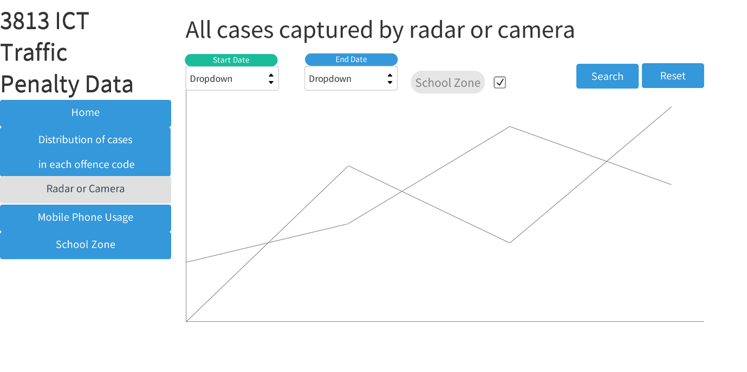

If User click start date the calendar will be displayed and user cans select the date or they can input the date “DD-MM-YY” form, it also applies for end date. In addition, user can tick the school zone box so they can search only the cases captured by radar or camera in school zone. After user choose both start date, end date and school zone, user can click search to see the graph or click reset to reset the data.

## Cases caused by mobile phone usage

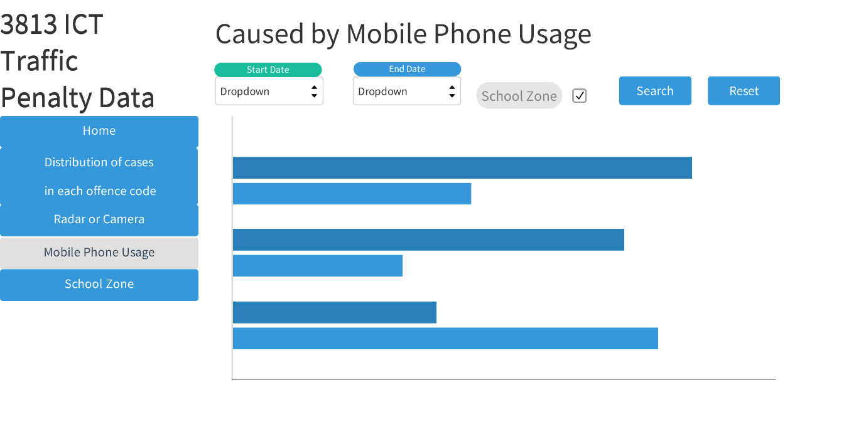

User can set period by using start date and end date at the top of page. User also can only see the data that happen in school zone by ticking school zone check box. After all the conditions have made, the suer can click search button to see the data about selected conditions. If user want to clear all the condition, then user needs to click reset button.

## Penalty caused in School Zone

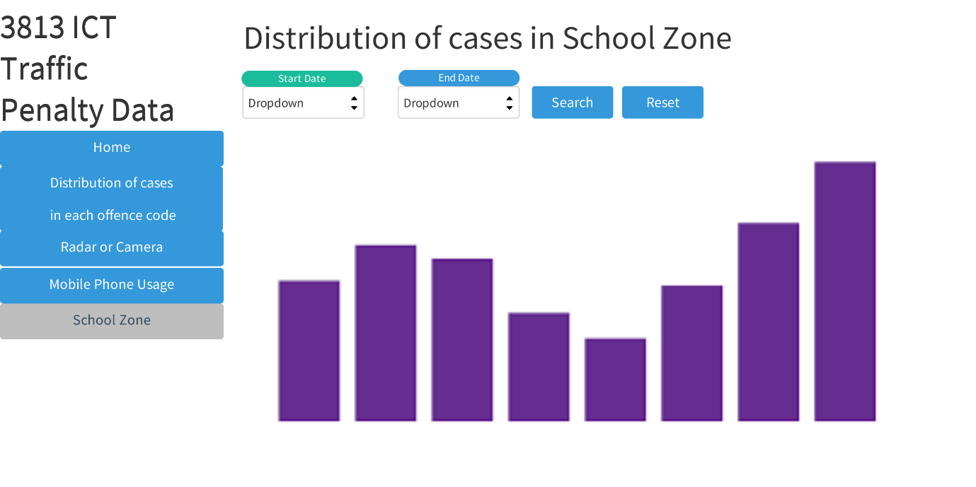

In this page user can select period by choosing start date and end date. If the user click search button after user set the period, then the cases in school zone during selected period will be displayed as bar graph. After that, user can click reset button to clear the period and can set another period. As same as other pages, user can go to other page using navigation bar that locate left side of page.

# Reference

1. Australian Bureau of Statistics. (28/06/2022). National, state and territory population

https://www.abs.gov.au/statistics/people/population/national-state-and-territory-population/latest-release